

Clinical Psychospiritual Education (CPE) at Providence Health Care

Spiritual Care

Spiritual Care embraces a holistic approach, attending to an
individual’s beliefs, values, behaviors and experiences related to spirituality, religion, culture and/or transcendence in an effort to develop relatedness, wholeness, healing, meaning, and purpose.

What is CPE?

Units of Clinical Psychospiritual Education (CPE) offer 200 hours of supervised practice within a variety of settings (health care, prisons, congregations) for individuals, their families, and friends who are experiencing various levels of crisis or spiritual distress. The remaining 200 hours include: peer and group supervision, case study presentations, individual supervision, and other structured learning activities (seminars, didactics, role plays, skill integration exercises).
Written assignments allow participants to integrate foundational theories (psychological, sociological, theological/religious, and spiritual) and to grow in their competencies related to the facilitation of healing, the safe and effective use of self, the building of collegial and inter-professional relationships, the development of professional responsibilities, and the assimilation of recent and relevant research.

What is a Residency?

Our residency is a nine-to-twelve-month full-time program, which offers three back-to-back units of full-time CPE. You must already have completed one unit of CPE, and have the required graduate level courses to be accepted into the residency.

Academic Requirements

The following is necessary for certification with CASC/ACSS: official transcripts, diplomas, or other evidence of completion of a qualifying two-year graduate/master’s degree in theology or a clinical related field, from an educational institution accredited by the Association of Theological Schools (ATS) or Council for Higher Education Accreditation.
Where a candidate is lacking either of the above, confirmation of equivalency must be obtained from the Academic Assessment Committee.

Elements of Clinical Psychospiritual Education

Case Conferences Students present reports of psychospiritual care encounters for discussion, analysis, and evaluation in a peer group setting.

Interpersonal Relationships Group (IPR) This group experience provides an opportunity for students to become self-aware in a safe space. Students reflect on how their attitudes, values, and assumptions affect their practice.

Didactic Seminars Resource persons lead didactic presentations from various fields within healthcare, covering a broad and dynamic range of issues.

Individual Supervisory Sessions These one-to-one conversations with the teaching supervisor provide the student an opportunity for professional consultation and support in fulfilling program requirements.

Our Program

The CPE curriculum is designed to develop learning of the competencies identified by the Canadian Association for Spiritual Care (CASC) as core skills required for anyone who wishes to provide care in this field. Providence Health Care (PHC) has continued with uninterrupted standing as a CASC-accredited Teaching Centre as a
legacy of its incorporation of St. Paul’s Hospital’s CPE program which began 30 years ago. Our CPE program is indeed celebrating its 30th Anniversary in 2024.
CPE at Providence Health Care is offered in conjunction with an affiliation agreement between PHC and the Vancouver School of Theology (VST). All CPE students are registered through VST and academic course credit is available as part of various programs and/or may be applied towards requirements related to field education or ordination in a number of traditions.
Located in Vancouver, British Columbia, Providence Health Care is a complex of eight health care facilities, founded by five different congregations. Healthcare at Providence is delivered through program-based care.

Our Students

We welcome applications from all applicants interested in exploring the field of spiritual care – whether for personal growth or a potential career. CPE programs are open to all irrespective of race, gender, age, faith group, national origin, sexual orientation, or physical ability.

A program will not be held for less than three students. In that case, every effort will be made to give the students ample notice of the program's cancellation, and students may be directed to an alternative program.

Our CPE Supervisor-Educator

Our teaching supervisor is a specialist in Spiritual Health and a Certified Supervisor- Educator according to the standards of the Canadian Association for Spiritual Care (CASC). The teaching Supervisor guides students as they learn the art and science of spiritual health and pastoral care.

Program Information
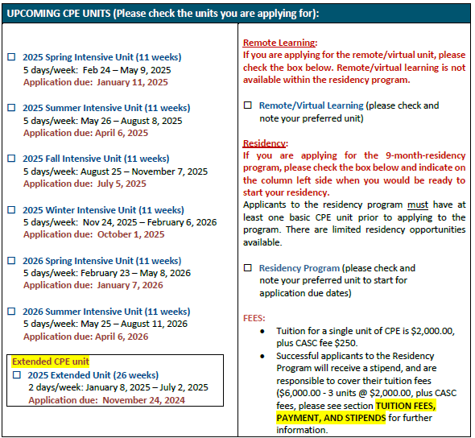

For further information and to request an application form, please contact:
Francis Lau CPE Teaching Supervisor-Educator
Providence Health Care / Spiritual Health and Pastoral Care Services
Mount St. Joseph Hospital – 3080 Prince Edward St. Rm. 4220, Vancouver, BC V5T3N4 Phone: 604-874-1141 ext. 78005, Cell: 604-364-1677, or Admin Sunday: 236-628-1330
Email: mlau19@providencehealth.bc.ca


I acknowledge with gratitude that I live and work on the traditional, ancestral and unceded territories of the Coast Salish peoples – the Musqueam, Squamish, and Tsleil-Waututh Nations. www.providencehealthcare.org

